Teacher Bio

Susan Rowell, ED.D.
Bois Blanc Pines School
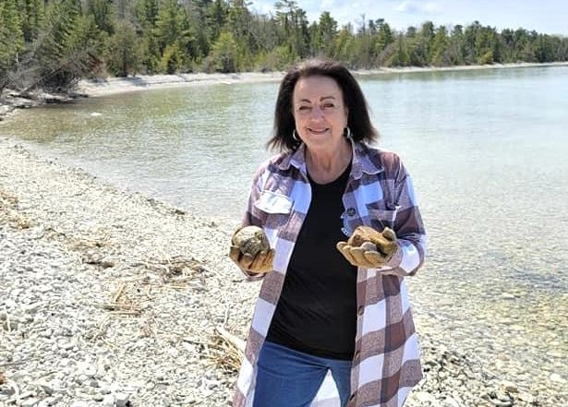

My Background
Hello! I am Dr. Susan Rowell and I am excited to be the teacher for Bois Blanc Pines School. I hold a Doctorate in Educational Administration in Transformational Leadership from Concordia University, and a Master of Education in Educational Leadership, and a Bachelor of Arts in Elementary Education, from Saginaw Valley University. I have been an educator for 28 years with a focus on data driven best practices in instruction and assessment and also school system change processes.

About Me

In addition to being a lifelong learner, I greatly enjoy family time and travel. While I have known my husband for over 50 years we have been married for 2 years. Along with my husband John, we have 3 children, 4 grandchildren, and 1 great granddaughter with another one on the way. I adore my dogs Lacey and Emma, and I also have a turtle named Turk. I am an avid rock collector and I enjoy the outdoors. I am interested in dementia and Alzheimer’s, and I like to keep updated on current events.

Contact

Should you wish to contact me, my number is 989-686-1104.

